Edward Snowden & the National Security Agency: Document Reading Homework

The United States Constitution: Fourth Amendment
The right of the people to be secure in their persons, houses, papers, and effects, against unreasonable searches and seizures, shall not be violated, and no Warrants shall issue, but upon probable cause, supported by Oath or affirmation, and particularly describing the place to be searched, and the persons or things to be seized.

What was the NSA doing?
“This brings me to the program that has generated the most controversy these past few months, the bulk collection of telephone records under Section 215. Let me repeat what I said when this story first broke. This program does not involve the content of phone calls or the names of people making calls. Instead, it provide a record of phone numbers and the times and length of calls, metadata that can be queried if and when we have a reasonable suspicion that a particular number is linked to a terrorist organization.”
-President Obama

What does the government think of Snowden’s leak?
“Intelligence agencies cannot function without secrecy, which makes their work less subject to public debate. Yet there is an inevitable bias, not only within the intelligence community but among all of us who are responsible for national security, to collect more information about the world, not less. So in the absence of institutional requirements for regular debate and oversight that is public as well as private or classified, the danger of government overreach becomes more acute. And this is particularly true when surveillance technology and our reliance on digital information is evolving much faster than our laws.

Given the fact of an open investigation, I’m not going to dwell on Mr. Snowden’s actions or his motivations. I will say that our nation’s defense depends in part on the fidelity of those entrusted with our nation’s secrets. If any individual who objects to government policy can take it into their own hands to publicly disclose classified information, then we will not be able to keep our people safe, or conduct foreign policy. Moreover, the sensational way in which these disclosures have come out has often shed more heat than light, while revealing methods to our adversaries that could impact our operations in ways that we might not fully understand for years to come.”
-President Obama

Surveillance and Civil Liberties
“In fact, even the United States proved not to be immune to the abuse of surveillance. In the 1960s government spied on civil rights leaders and critics of the Vietnam War. And probably in response to these revelations, additional laws were established in the 1970s to ensure that our intelligence capabilities could not be misused against our citizens. In the long twilight struggle against communism, we had been reminded that the very liberties that we sought to preserve could not be sacrificed at the altar of national security.

It is hard to overstate the transformation America’s intelligence community had to go through after 9/11. Our agencies suddenly needed to do far more than the traditional mission of monitoring hostile powers and gathering information for policymakers.

And yet, in our rush to respond to a very real and novel set of threats, the risk of government overreach, the possibility that we lose some of our core liberties in pursuit of security also became more pronounced. We saw in the immediate aftermath of 9/11 our government engage in enhanced interrogation techniques that contradicted our values. As a senator, I was critical of several practices, such as warrantless wiretaps. And all too often new authorities were instituted without adequate public debate.

We have to make some important decisions about how to protect ourselves and sustain our leadership in the world while upholding the civil liberties and privacy protections our ideals and our Constitution require. We need to do so not only because it is right but because the challenges posed by threats like terrorism and proliferation and cyber-attacks are not going away any time soon. They are going to continue to be a major problem. And for our intelligence community to be effective over the long haul, we must maintain the trust of the America people and people around the world.”
-President Obama

Plan to Change NSA’s Policies
“Effective immediately, we will only pursue phone calls that are two steps removed from a number associated with a terrorist organization, instead of the current three, and I have directed the attorney general to work with the Foreign Intelligence Surveillance Court so that during this transition period, the database can be queried only after a judicial finding or in the case of a true emergency.
Next, step two: I have instructed the intelligence community and the attorney general to use this transition period to develop options for a new approach that can match the capabilities and fill the gaps that the Section 215 program was designed to address, without the government holding this metadata itself. They will report back to me with options for alternative approaches before the program comes up for reauthorization on March 28th. And during this period, I will consult with the relevant committees in Congress to seek their views and then seek congressional authorization for the new program, as needed.

As the nation that developed the Internet, the world expects us to ensure that the digital revolution works as a tool for individual empowerment, not government control. Having faced down the dangers of totalitarianism and fascism and communism, the world expects us to stand up for the principle that every person has the right to think and write and form relationships freely, because individual freedom is the wellspring of human progress.

Those values make us who we are. And because of the strength of our own democracy, we should not shy away from high expectations. For more than two centuries, our Constitution has weathered every type of change because we’ve been willing to defend it and because we’ve been willing to question the actions that have been taken in its defense. Today is no different. I believe we can meet high expectations. Together, let us chart a way forward that secures the life of our nation while preserving the liberties that make our nation worth fighting for.”
-President Obama

Politicians React to NSA Collecting Phone Data http://www.huffingtonpost.com/2013/10/30/edward-snowden-poll_n_4175089.html
- Sen. Dianne Feinstein (D-Calif.) said the court order for telephone records was part of a three-month renewal of an ongoing practice, the Associated Press reported. "It’s called protecting America," Feinstein said at a Capitol Hill news conference.
- Sen. Mark Udall (D-Colo.) said "the administration owes the American public an explanation of what authorities it thinks it has."
- Senate Majority Leader Harry Reid (D-Nev.) thought everyone "should just calm down." "Right now I think everyone should just calm down and understand this isn't anything that's brand new," Reid said
- Sen. Jeff Merkley (D-Ore.) said in a statement: "This type of secret bulk data collection is an outrageous breach of Americans’ privacy."
- Sen. Lindsey Graham (R-S.C.) said he was "glad" the NSA was collecting phone records. "I don’t mind Verizon turning over records to the government if the government is going to make sure that they try to match up a known terrorist phone with somebody in the United States," Graham said in an interview on "Fox and Friends."
- Sen. Saxby Chambliss (R-Ga.) also claimed that reports of the NSA collecting phone records was "nothing particularly new." "Every member of the United States Senate has been advised of this," Chambliss said. "And to my knowledge we have not had any citizen who has registered a complaint relative to the gathering of this information."
- Sen. Bob Corker (R-Tenn.) found the NSA collecting phone records "troubling." "The fact that all of our calls are being gathered in that way -- ordinary citizens throughout America -- to me is troubling and there may be some explanation, but certainly we all as citizens are owed that, and we're going to be demanding that," Corker said.

Motive: Quotes from Edward Snowden
“For me, in terms of personal satisfaction, the mission's already accomplished. I already won. As soon as the journalists were able to work, everything that I had been trying to do was validated. Because, remember, I didn't want to change society. I wanted to give society a chance to determine if it should change itself. All I wanted was for the public to be able to have a say in how they are governed.”

“I believe in the principle declared at Nuremberg in 1945: ‘Individuals have international duties which transcend the national obligations of obedience. Therefore individual citizens have the duty to violate domestic laws to prevent crimes against peace and humanity from occurring.’”

Public Opinion
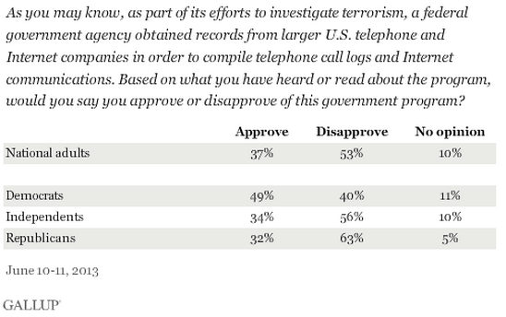 | 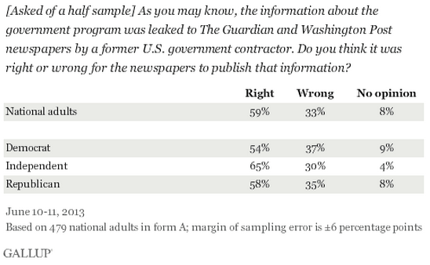
Political Cartoons
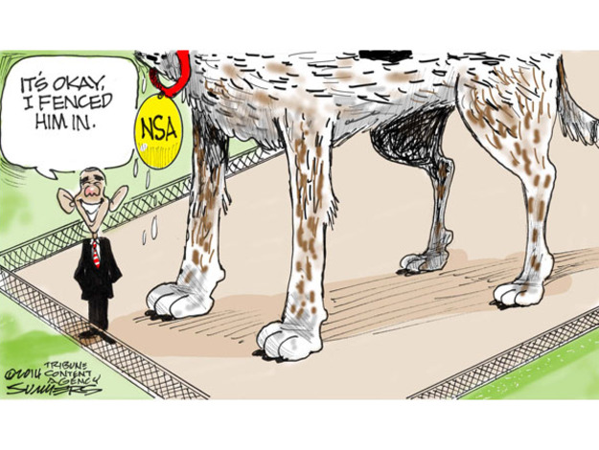 |  | 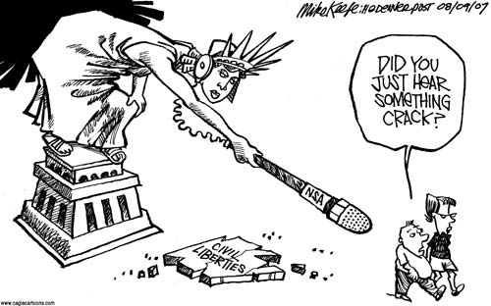
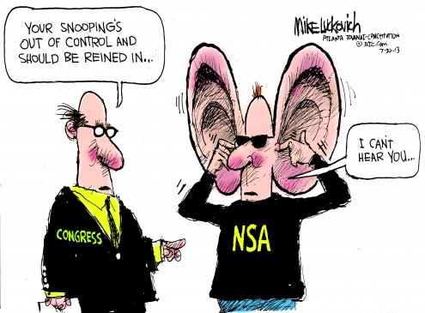 |  | 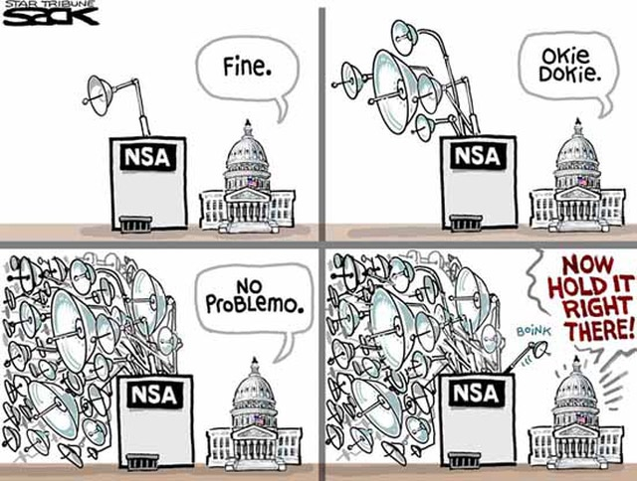
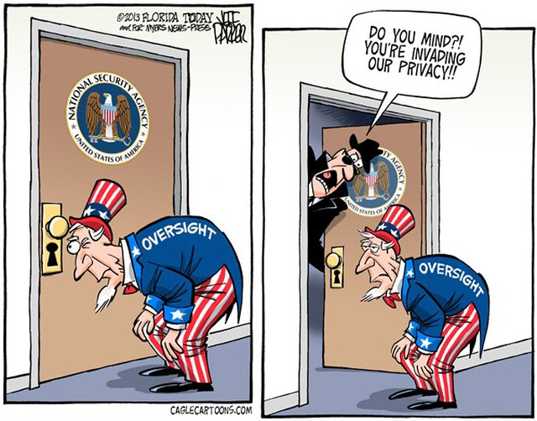 |  | 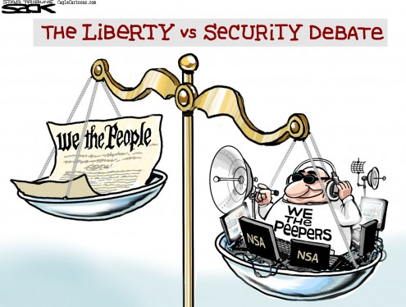

Questioning Skills: In the box to the left write down three questions that were raised as you read the different documents. These questions should be researchable with definitive answers. In the box to the right, write down three open-ended questions that could spark a class discussion.

Bonus: Find and print other documents/resources/current events on this topic that would be useful for a class discussion.
Edward Snowden & the National Security Agency: Class Discussion

Bell Work: You have just discovered that your parents have been getting your phone records from your service provider. Describe how it feels to have this invasion of privacy and make a claim as to whether or not your parents have this right.

Discussion Timeline:
- Bell Work: 5 Minutes
- Building Evidence (Review Homework Reading & Text Mark): 10 Minutes
- Discussion 1, does the government have the right of public surveillance? 10 Minutes
- Discussion 2, what is more important, privacy or security? 10 Minutes
- Discussion 3, is Snowden a hero or traitor? 10 Minutes
- Wrap Up Synthesis: 5 Minutes

Discussion Notes: Record the following information in the boxes provided as you discuss the questions at hand.
Evidence I used to defend my claim for discussion one… | Evidence I used to defend my claim for discussion two… | Evidence I used to defend my claim for discussion three…

Wrap Up Synthesis: To synthesize means to combine a number of things into a coherent whole. Synthesize your perspectives in the different discussions to create one evaluation of bureaucracy and the NSA.

